Day 2 Assignment 1

LetsUpgrade – Javascript Essentials

Name: k kavya

e-mail id : [kavya.kguru@gmail.com](mailto:kavya.kguru@gmail.com)

Question 1 : Write a JavaScript program to display the current day and time in the following format. Sample Output : Today is : Tuesday. Current time is : 10 PM : 30 : 38

<html>

<head>

</head>

<body>

<p><h3>Today is</h3>

</P>

<script>

document.write(Date());

</script>

</body>

</html>

OUTPUT SCREENSHOT:

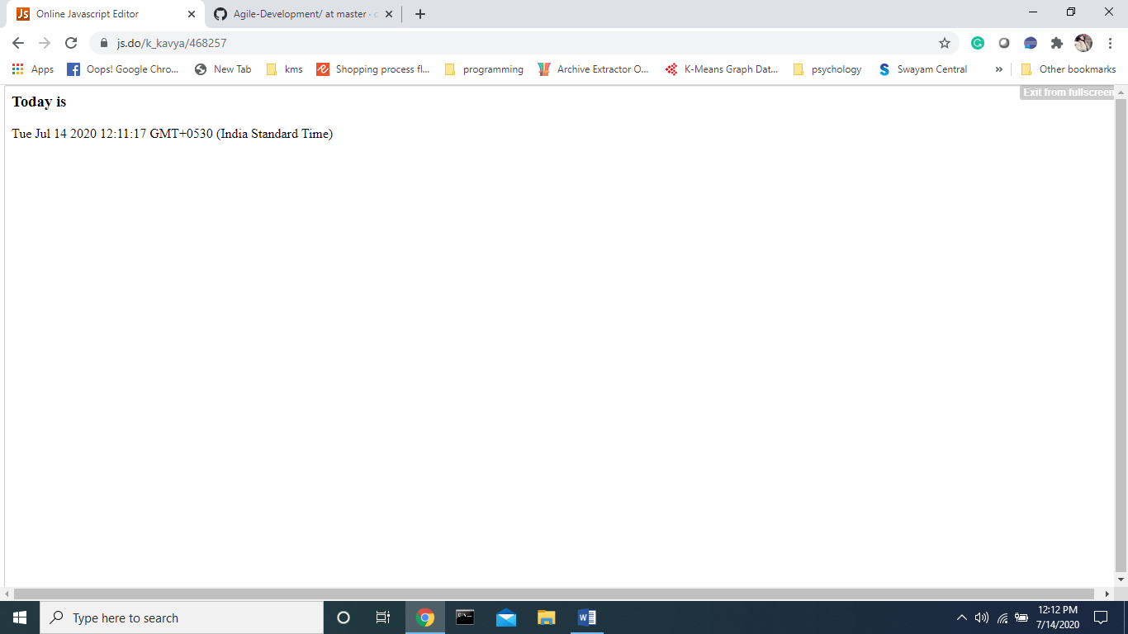

**Question 2 :**

Write a JavaScript program to print the contents of the current window.

<html>

<head>

<h1> KAVYA's Page</h1>

<body>

<button onclick="window.print()"> PRINT THIS PAGE</button>

</body>

</html>

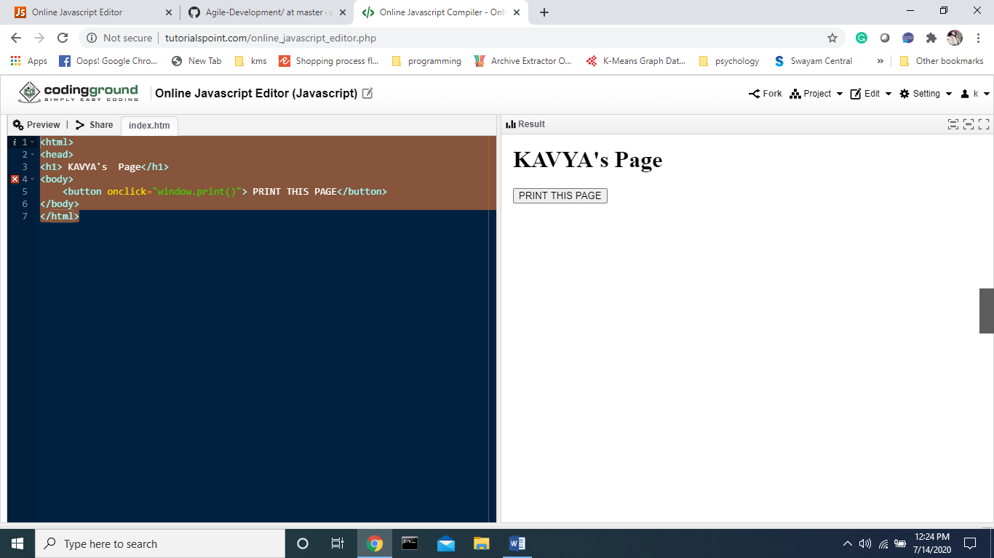

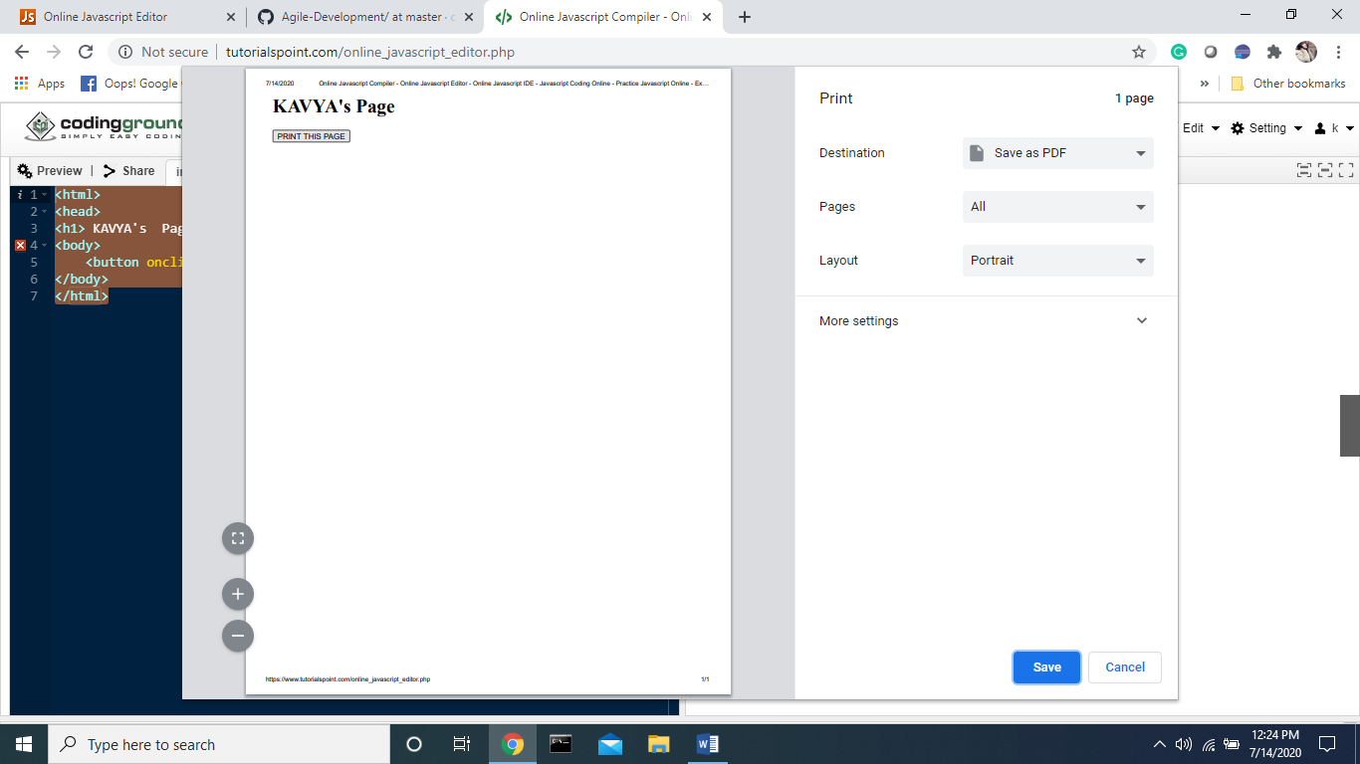

**Question 3 :**

Write a JavaScript program to get the current date.

Expected Output : mm-dd-yyyy, mm/dd/yyyy or dd-mm-yyyy, dd/mm/yyyy

<html>

<body>

<head>

<h1> Today's day is </h1>

</head>

<script type="text/javascript">

var d = new Date()

document.write(d.getDate())

document.write(".")

document.write(d.getMonth() + 1)

document.write(".")

document.write(d.getFullYear())

</script>

</body>

</html>

